Math 8 Application 6 Name ________________________
Show all your work!

1. Circle the letter that represents the approximate location on the number line of $\sqrt{85}$.  A B C D  0 5 10 15 | 2. Write using a negative exponent:  $\frac{1}{16}$ = | 3. Solve for x:  x² = 121
4. Write in scientific notation.  324,000,000 | 5. Write the quotient in scientific notation.  (9.6 ∙ 10⁵) ÷ (2.4 ∙ 10³) = | 6. Solve for x.  2x – 13 = 12x + 7
7. If the line segment below was translated up 3, right 4, name the coordinates of the endpoints.  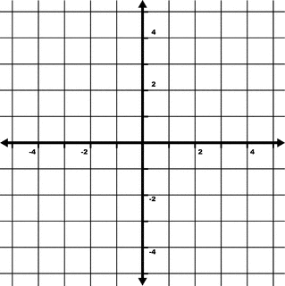 | 8. Find the length of side a below.  8 in. a  12 in. | 9. Find the measure of angle b.  b  42°
10. Put the following rational numbers in order from smallest to largest.  -3/4, -2/5, -.25, -.34 | 11. Estimate the sum below.  2,456,890 + 35,985 = | 12. Write as percent.  .78
13. Jeff owes his mom $2. In order to pay her back he takes a job picking weeds. He earns $1 for every three weeds he pulls.  Write an equation for the function. | 14. Graph Jeff’s function.  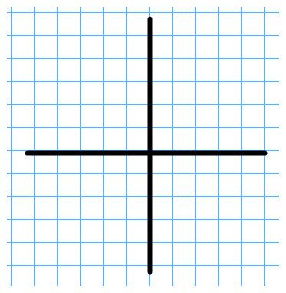 | 15. Complete the table.
  Weeds  Pulled | Jeff’s Money
  0
  9
  600
16. What is the sale price of a pair of $30 jeans that is marked 25% off? | 17. Find the volume of a sphere with a radius of 5 cm. | 18. A seamstress used 38 feet of ribbon on 14 dresses. How much ribbon was used per dress?
19. Juan’s quiz scores are 3, 7, 5, 8, and 10. What is the mean of his quizzes? | 20. The inchworm traveled 6 feet one day and then 24 inches the next day. How many total yards were traveled? | Number correct  5 minutes_______  Total___________

